WEEK #6
1# A grading system compares three internal-assessment scores. Write a program to find the highest score among the three, using only if statements.
a = float(input("Enter 1st score : "))
b = float(input("Enter 2nd score : "))
c = float(input("Enter 3rd score : "))
if a < 0 or b < 0 or c < 0:
print("Invalid score entered")
d = a
if b > a and b > c:
d = b
if c > b and c > a:
d = c
print("Highest score is: ", d)
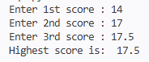
2# A sensor module collects readings from three temperature probes. Write a program to determine the lowest reading using if–else logic.
a = float(input("Enter temperature 1: "))
b = float(input("Enter temperature 2: "))
c = float(input("Enter temperature 3: "))
if b < a:
if b < c:
d = b
else:
if c < a:
d = c
else:
d = a
if a < 0 or b < 0 or c < 0:
print("Invalid score entered")
print("Lowest score is: ", d)
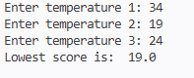
3# Write a program to check a year for leap year. (Use if and else)
year = int(input("Enter year: "))
if year > 0:
if (year % 4 == 0 and year % 100 != 0) or (year % 400 == 0):
print("Leap Year")
else:
print("Not a Leap Year")
else:
print("Not a valid year")
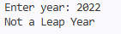
4# Write a program to print number of days in a month. (Chained Conditional)
month = int(input("Enter month (1-12): "))
if month >= 1 and month <= 12:
year = int(input("Enter year: "))
if year >= 0:
m = [1, 3, 5, 7, 8, 10, 12]
if month in m:
print("31 days")

elif month == 2:
if (year % 4 == 0 and year % 100 != 0) or (year % 400 == 0):
print("29 days")
else:
print("28 days")
else:
print("30 days")
else:
("Not a valid year")
else:
print("Not a valid month")
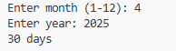
5# Write a Python program that takes a month (1–12) and a year, uses a list of days in each month, and prints the correct number of days. Make sure of leap year for February.
month = int(input("Enter month (1-12): "))
year = int(input("Enter year: "))
days = [31, 28, 31, 30, 31, 30, 31, 31, 30, 31, 30, 31]
if month == 2:
if (year % 400 == 0) or (year % 4 == 0 and year % 100 != 0):
print(29)
else:
print(28)
elif 1 <= month <= 12:
print(days[month - 1])
else:
print("Invalid month")
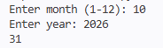
6# An architectural software checks the type of triangular panels used in design. Write a program to: • Compute the area of a triangle using its three sides. • Print whether it is equilateral, isosceles, or scalene.
import math
print("Enter sides of triangle: ")
a = float(input("Enter 1st side : "))
b = float(input("Enter 2nd side : "))
c = float(input("Enter 3rd side : "))
if (a > 0 and b > 0 and c > 0):
if (a+b > c and b+c > a and a+c > b):
if (a == b or b == c or a==c):
print("Isosceles Triangle")
elif (a == b and b == c):
print("Equilateral Triangle")
else:
print("Scalene Triangle")
s = (a+b+c)/2
area = math.sqrt(s*(s-a)*(s-b)*(s-c))
print("Area is: ", area)
else:
print("These sides cant form a triangle")
else:
print("Invalid length")
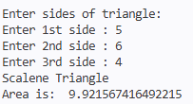
7# A device logs data indexes between two given IDs. Given two numbers r1 and r2 (r1 < r2): Write a program to create a list of integers from r1 to r2 (inclusive) using range().
r1 = int(input("Enter r1: "))
r2 = int(input("Enter r2: "))
numbers = list(range(r1, r2 + 1))
print(numbers)
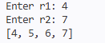

8# A parser receives a mixed list of characters, symbols, and integers. Write a program to extract and add only numeric items using isinstance(). Example 1: • Input: [1, 2.5, 3, -4] • Output: 0 Example 2: • Input: [10, -5, 20] • Output: 25
n = int(input("Enter the number of list elements: "))
l = []
for i in range(n):
m = input(f"Enter list element {i+1}: ")
if m.lstrip('-').isdigit():
l.append(int(m))
else:
l.append(m)
print(l)
total = 0
for i in l:
if isinstance(i, int):
total += i
print(total)
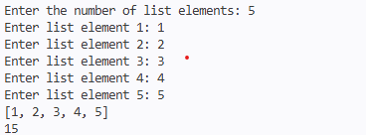

9# A game engine verifies whether level IDs are arranged in a proper continuous sequence. Write a Python program to check whether a given list of numbers is consecutive. Example 1: • Input: [4, 2, 3, 5] • Output: True • Input: [1, 2, 2, 3] • Output: False
n = int(input("Enter the number of list elements: "))
l = []
for i in range(n):
m = input(f"Enter list element {i+1}: ")
l.append(int(m))
print(l)
l.sort()
print(l)
consecutive = True
for i in range(len(l) - 1):
if l[i+1] - l[i] != 1:
consecutive = False
break
print(consecutive)
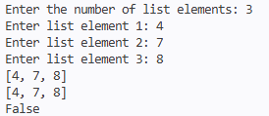
10# Given an integer n, return a string array answer (1-indexed) where: • answer[i] == "FizzBuzz" if i is divisible by 3 and 5. • answer[i] == "Fizz" if i is divisible by 3. • answer[i] == "Buzz" if i is divisible by 5. • answer[i] == i (as a string) if none of the above conditions are true. Example : Input: n = 15 Output: ["1","2","Fizz","4","Buzz","Fizz","7","8","Fizz","Buzz","11","Fizz","13"," 14","FizzBuzz"]
n = int(input("Enter n: "))
list = []
for i in range(1, n + 1):
if i % 3 == 0 and i % 5 == 0:
list.append("FizzBuzz")
elif i % 3 == 0:
list.append("Fizz")
elif i % 5 == 0:
list.append("Buzz")
else:
list.append(str(i))
print(list)
